LOHANA SCHOOLS
P.1 ENGLISH REVISION WORK: 2020
ACTIVITY THREE.

Name:………………………………………………Stream:………..
- Fill in the missing letters.
m __ n w __ m __ n c h __ l d b __ b __
- Write the opposite.
mother ________________
brother ________________
good ________________
boy ________________
man ________________
- Read and draw.
sister | father | brother | mother

Mother is cooking food | The teacher is teaching | Jane is cleaning the table

LOHANA SCHOOLS
P.1MATHS REVISION WORK ACTIVITY ONE: 2020

Name:…………………………………………….Stream:………….
- Circle the smallest number.
- 0 , 1 , 2
- 4 , 6 , 3
- 30 , 10 , 20
- Draw these sets.
- A set of 3 flowers.

- A set of 2 bags.

- An empty set.

- A set of 4 boys.

P.1 READING REVISION WORK ACTIVITY ONE: 2020
Name:……………………………………………….Stream:…………
  - Write six words with sound ‘ee’
i)________________ ii)______________ iii)______________ iv)_______________ v)_____________vi) _______________
  - Join and form words.
ink + pot = ________________________
black + board = ____________________
tea + pot = _________________________
bath + room = _____________________
bed + room = ______________________
  - Make good sentences.
    - _____________________________________

    - 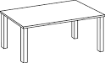
    - 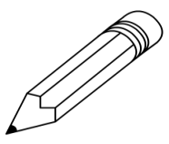
    - 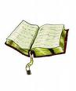

    - _________________________________

P.1 RELIGIOUS EDUCATION REVISION WORK ACTIVITY ONE: 2020

Name:……………………………………………..Stream:…………
- Write down two Moslem names.
a) _______________________ b) _______________________
- Circle three Christian names.
John Amina Mary Sharifa Peter Abdul
- Match correctly.
nose for walking
eyes for smelling
legs for hearing
ears for seeing
- Name the parts of the leg.
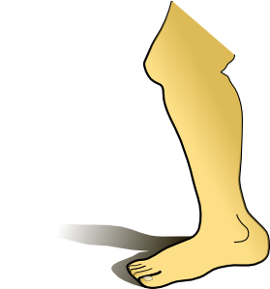
(toes, thigh, ankle, heel, knee, calf, foot, leg)

P.1 LITERACY REVISION WORK ACTIVITY ONE: 2020
Name:……………………………………..Stream:………..…
- Fill in the missing letters.
r___ading wr___ting s___nging
d___ncing l___arning sl___shing
sk___pping runn___ng
- Name these activities done at school.
 | 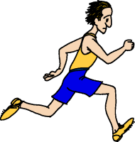 | 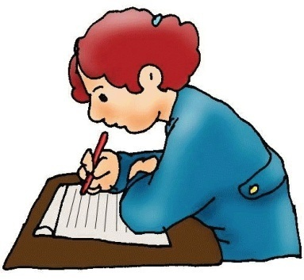
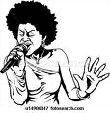 | 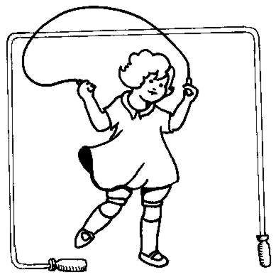 | 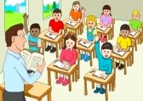
- Write any two activities done in class.
- ____________________________________________________
- ____________________________________________________

